Eugene Fotsing

CTEC298-101

Professor Bemley

**Tableau Plot Tutorial**

* **Bar Chart**

This chart uses an excel file that provide data about house ownership in California. The Bar chart use the race feature as column and the income rows. A modification on the values chow on the Income has been made to display the average of what each race earns.

Axis Label Have been also modified to fit the context of the chart.

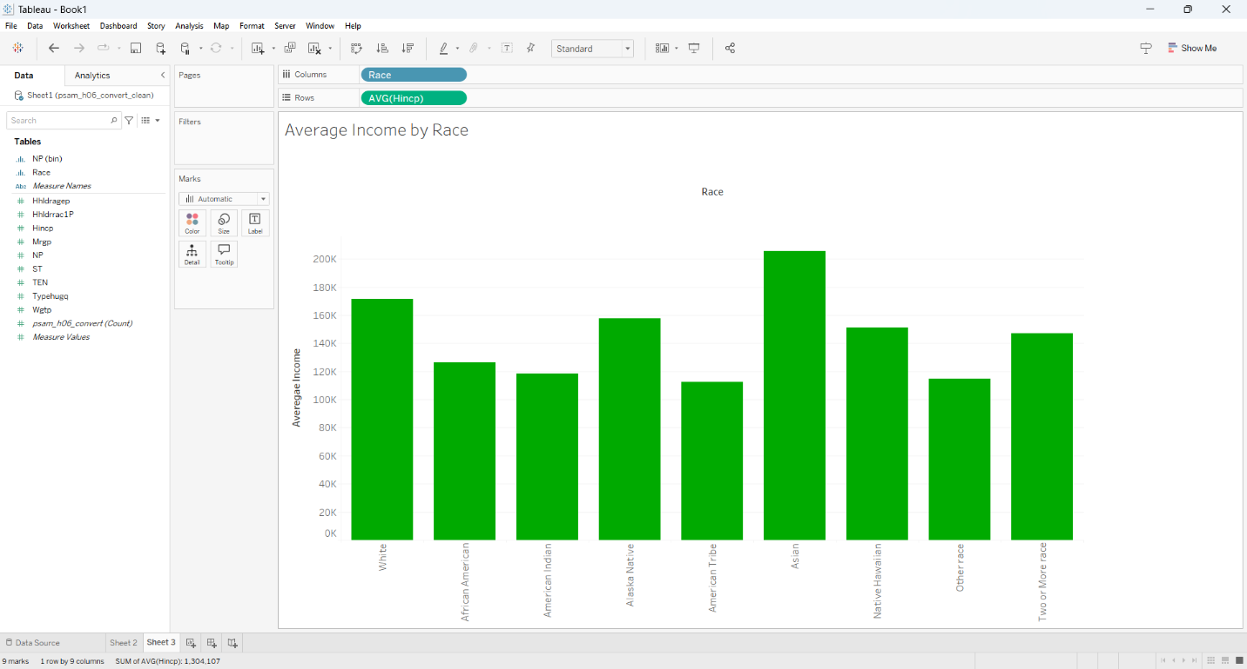

* **Pie Chart**

This chart uses an excel file that provide data about house ownership in California. The Pie chart use the race feature as labels and values for this chart. Aliases have been used to separate each different race. Then a modification on the race have been made to effectuate a count of each race.

The palette of color have been change to make each race distinct from each other.

